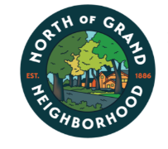
Date: March 11, 2026
- Attendance:

President: Marshall James
Vice President: Mark Sigfried
Treasurer: Tom Wollans
Secretary: Lisa Deaton
Alix Lifka-Reselman
Sarah Shaffer - Absent
Jordan Bailey
Daniel Carpentry
Elliot Klimowski
Tom Wollans
Amy Garza
Lu Spain
Mollie Sabo
Eugen Burianov

Priority Planning
- SPECIAL PRESENTATION: Developing a Strategic Plan - Heather Tamminga, Neighborhood Outreach Coordinator
  - Heather discussed what other neighborhoods have done for Strategic Planning.
  - Heather has recommended professional leaders who can facilitate a strategic planning for a fee.
  - Lu and Lisa met with one set of leaders.
  - Neighborhoods have different options of how far out they’d like the planning to go. One neighborhood did a 90 day strategic plan which worked well for them.
  - The board could engage with residents to obtain their opinion on needs/wants.
    - How we’d engage with the residents on what they want – scan a QR code to get the Survey.
    - We can have ideas that pre-show on a survey
    - Add to what the board has determined are areas of focus.
    - What does NoG look like in one year, two years etc.?

- Heather liked the NoG approach of new ideas brought to the board from members and ideas coming from within the board:
  - Who is going to lead the initiative? Who are the participants? Who will do the work – are volunteers needed?
  - What is the event/project?
  - Where is the location?
  - Why - Does it align with our mission statement and Priority Plan?
  - How is the event/project advertised?
  - What are the costs?

- When asked who could facilitate the Priority Planning for NoG – she stated a project manager type, a former board member and Heather volunteered her services to facilitate the planning sessions for us.
  - We could do this in 3-4 hours in 2-3 meetings with perhaps a few ideation sessions
The board liked the verbiage Priority Planning instead of Strategic Planning.

Lu asked if we don’t do a Priority Plan what the potential pit falls. Heather’s response was we’d still accomplish tasks, events and projects but we won’t necessarily address the needs of the neighborhood and we won’t know if we are hitting the mark on where we’d like to be in 2 years or predetermined timeframe.

We could set two priorities or maybe it’s one priority.
The Park and Board/organization structure for the board were two ideas floated for our area of focus.
Neighbors want a park playground park and Marshall suggested Organizational Order for NoG Board – being two example priorities floated.

Heather suggested we keep it to 1, 2 or 3 items for a two year plan.
One year plan 1-2 items. Any more than 3 is too many

  - Heather gave a high level example of a working template using a Word Table for our planning session where one page is one of our chosen areas of focus. NoG Park as a header then under that column it would have breakdowns of action items with timeframe of completed deliverables, resources needed from inside the association and outside the neighborhood such as City of Des Moines Parks and Recreation.
What resources do we need to find the location with a timeframe?

- Treasurer’s Report: See screen shots below
  - Tom has been checking the federal website for the 501.c3 status that NoG has applied for and so far he has not seen a result of our status approval. Heather stated it could take up to 9 months.
  - Tom heading up Tres report and Meeting Minutes to the City/Heather.
Financial responsibility is required as well. We put those financial controls into our bi-laws – heather stated that would have met the requirement.
  - Marshall will upload the meeting agenda’s, meeting minutes and treasurer’s reports with bank statements to Google Documents for Tom to send to the City of Des Moines in order to stay in compliance as a neighborhood association. For 2025 Heather requires May, Aug and Nov only.
  - Tom and Marshall will move to another bank that doesn’t charge for the debit cards – the board agreed to look at local banks like Banker’s Trust, Iowa State Bank and even credit unions as all of these are used is used by other neighborhood.
  - Per Heather - Polk County Betterment Grant is generally a good funder and it is fairly easy to apply – they open up in Dec.
- The Executive Committee will meet tomorrow Zoom Thu March 11 at 1:00 PM to discuss the NoG Bi-Laws.

- Executive Committee
  - Password management solutions – Eugen has a couple of solutions for $3 or $4 a month to maintain the passwords securely. We’d sign up on a family plan so the executive committee has access to passwords. You don’t want a free version – too easily hacked.
  - Bit Warden Account – will be our password management system.
  - Google will send out emails.
  - We need a new account to put the website name in. Marshall to do that.
  - We need a set of procedures when we have new board members.

- NoG to implement membership dues again. Elliot
  - Beaverdale dues system.
  - The City has a list of all the neighborhood associations and their required dues. They vary from individual, household, business, church and schools from association to association
  - When neighbors ask what they get for the membership dues - it appeals to people’s community pride.
    - How people get notified about the Dues are due –
    - Zeffy – a service that is a due’s paying Management Company
    - Drake neighborhood always lists their business leaders Heather can connect with downtown neighborhood is really good at showcasing their business dues.

- Bylaws Committee: Lu and Marshall
  - Executive Committee, Marshall, Lu, Lisa, Mark and Tom will meet Thursday, March 12 to review NoG Bylaws. Bylaws Review

- Green Committee: Mark, Amy and Lisa
  - Status of Rollins Ave beautification - Grant modified, new NoG Parks Committee will take up the 35th Street lighting for the 35th Street and Rollins underpass
  - Establishment of Park Subcommittee – we have a list of volunteers who signed up for the parks committee. Amy Garza is the chair of the committee. Lisa will send out an email to the people on the parks committee and Amy will follow up with subsequent meetings and action items.

- Events Committee:

  - Community Engagement Alix
Helping with new neighbor outreach and has logged those new neighbors.
- New Homeowner Spreadsheet

- DM Public Schools Marshall
    - DMPS proposing controversial changes to teacher’s health coverage; spreading Art, Music, and PE teachers among many buildings; and dropping the FOCUS program

- Old Business

- Center Street traffic calming - Jason Scholbrock
    - Survey for residents
- INVEST DSM -
    - Block Captain plan - back mapping
    - Block Challenge Grant coordination
- Ordering New Merch
    - Table Cloth
    - Stickers
    - Magnets - Alix will make small run?
    - Sandwich board, and Alix is going to refurbish the existing signs that alert neighbors of the meeting
    - Alix $1000 - postcard USPS does all of it, But Alix wants to work with Invest DSM finance the post its. Motion passed.

- 654 36th Street - Sober transitional house ran by Dads With a Purpose
- Lisa - Strategic Plan Development
- Event checklist - Who lead, how much money, how much personnel support
- Board Development Trainings

- New Business
- Paint the Pavement Project Proposal
- Traffic calming on 35th Street
- National Volunteer Week is April 19–26, 2025.
- Preparing for the NoG Neighborhood Yard Sale - Saturday, May 2 & Friday or Sun
    - Outreach to Salisbury Oaks, Woodland Heights
- Art Stroll In June

Treasurer’s Report for February 2026.
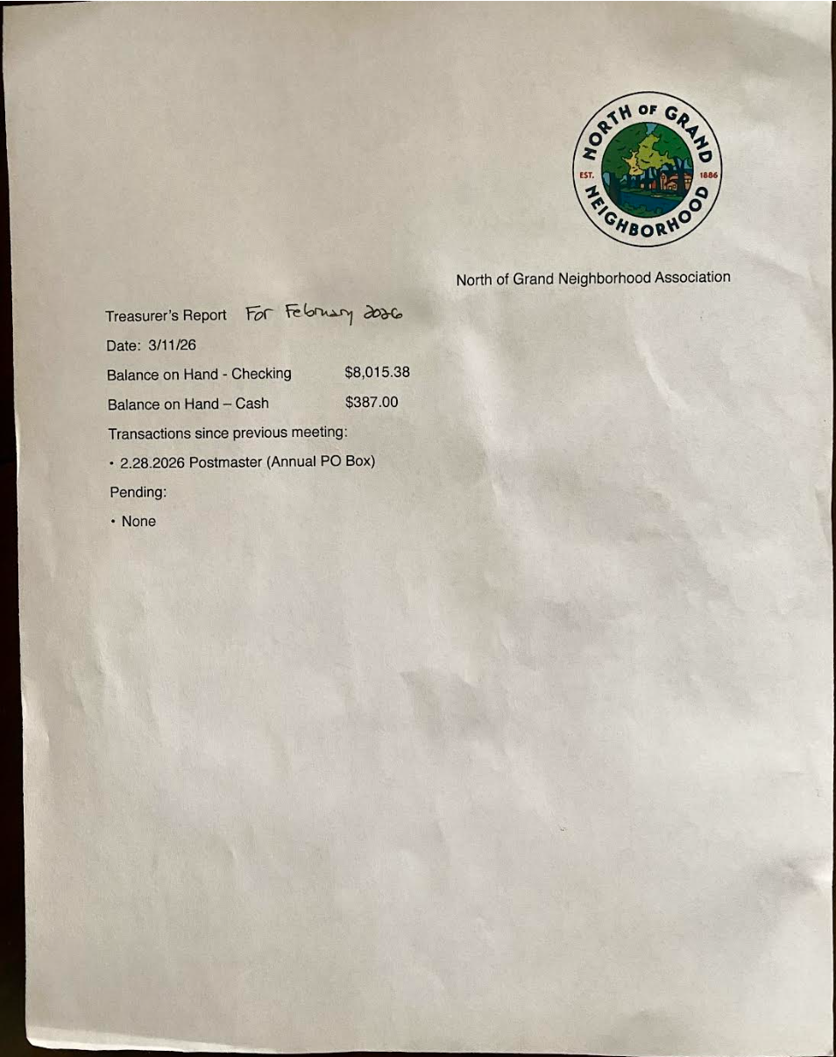
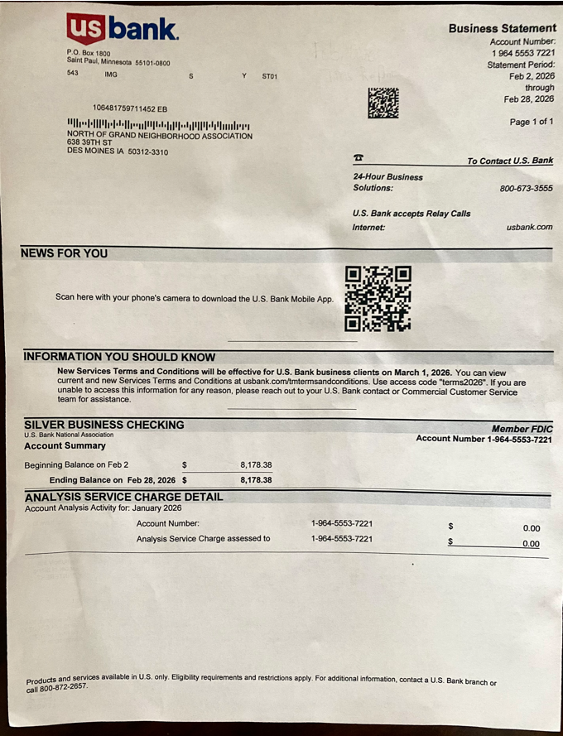

Meeting adjourned

